Coursework Part 2: Developing the webpages with HTML and CSS

Note that screenshots provided may differ visually depending on the monitor you’re using.

Main Game Page:

The big green box at the center is a placeholder for where the actual game window will be.

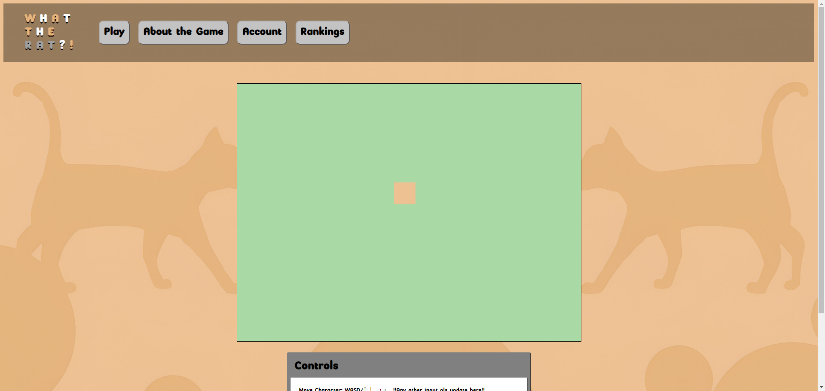



About the Game Page:

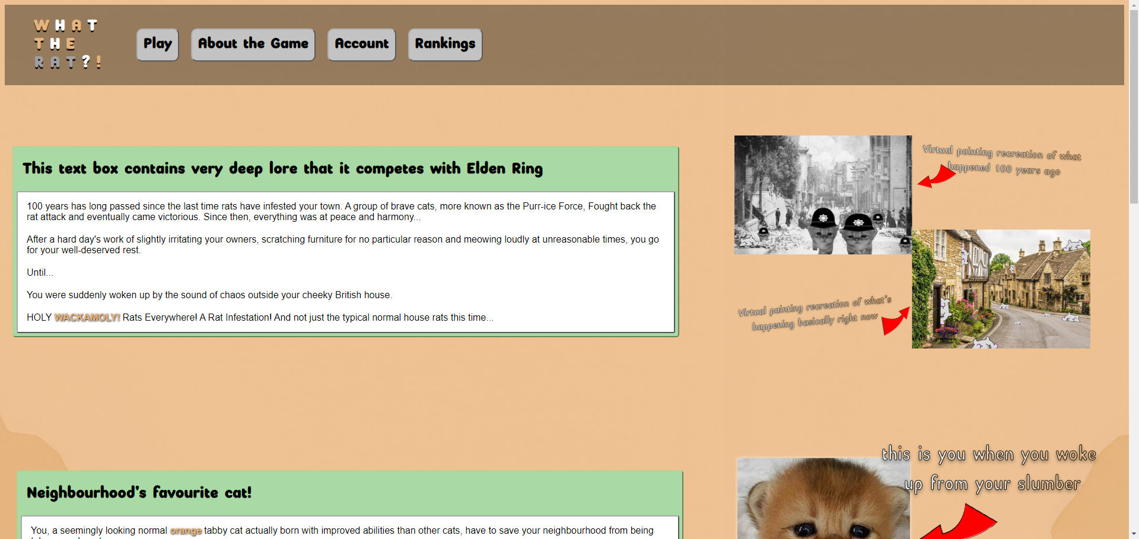

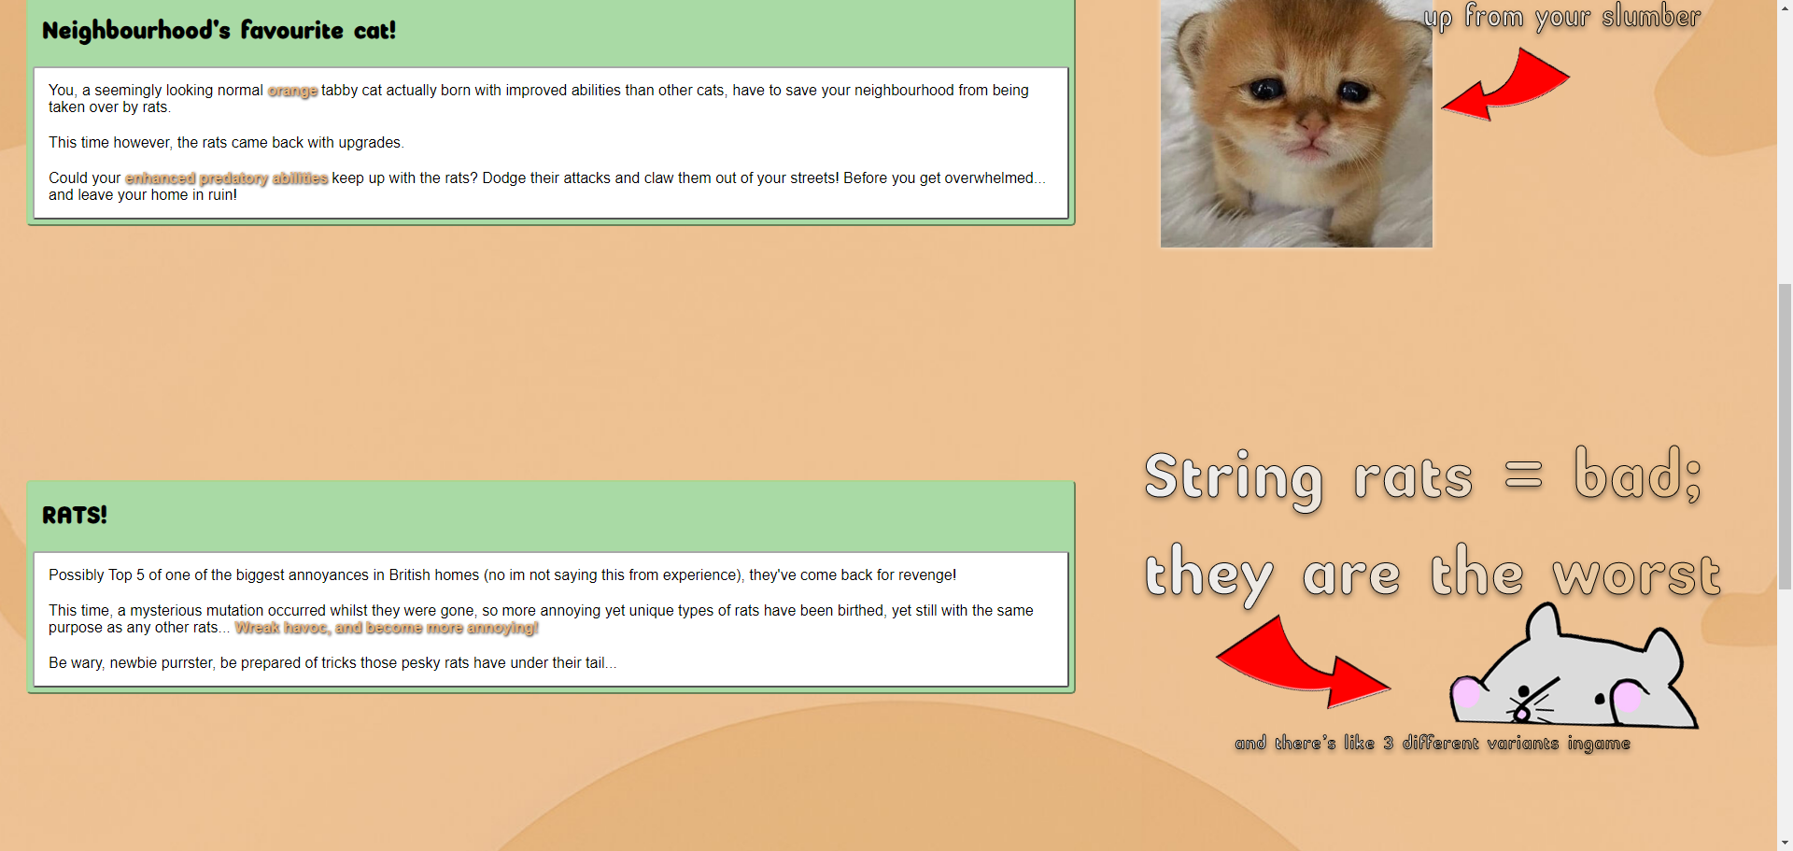

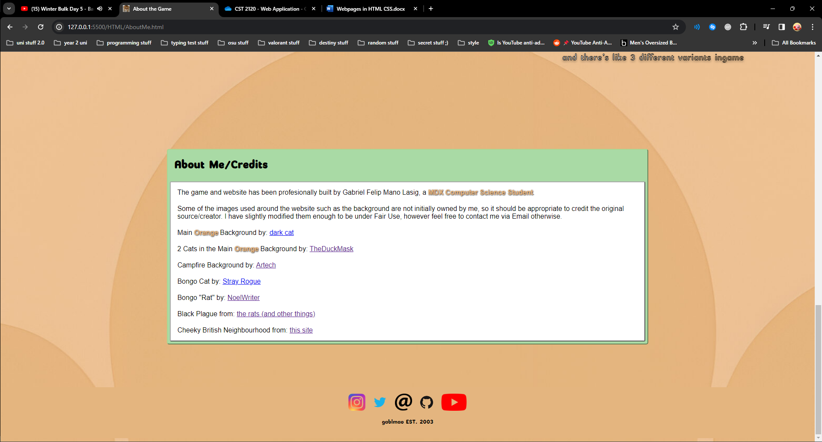

Account Page (when making account or logging in):

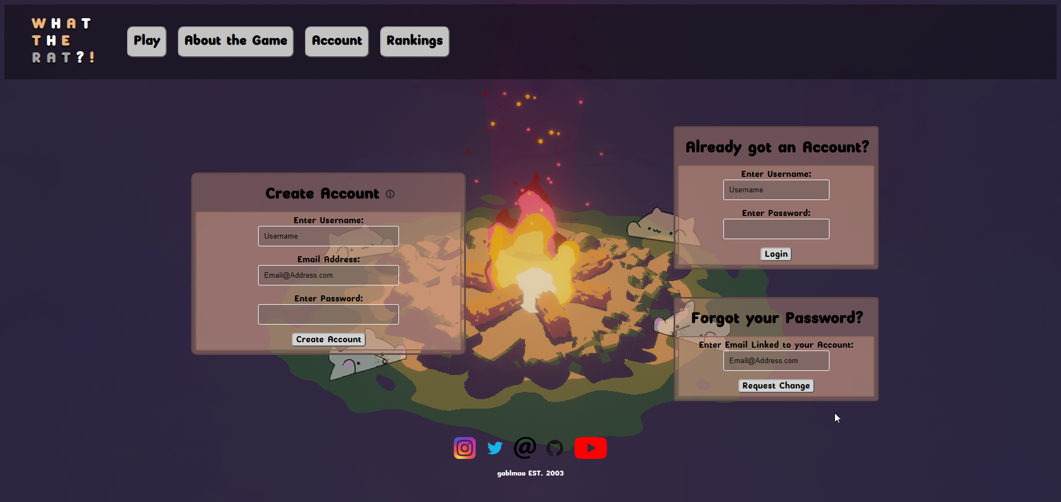

2nd Account Template Page (after making account or logging in):

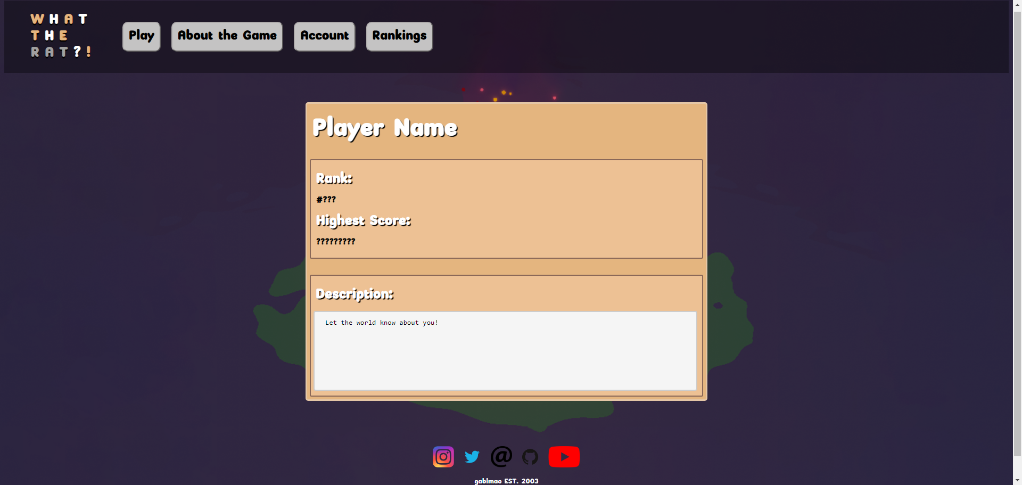

3rd Account Page (when user forgets their password):

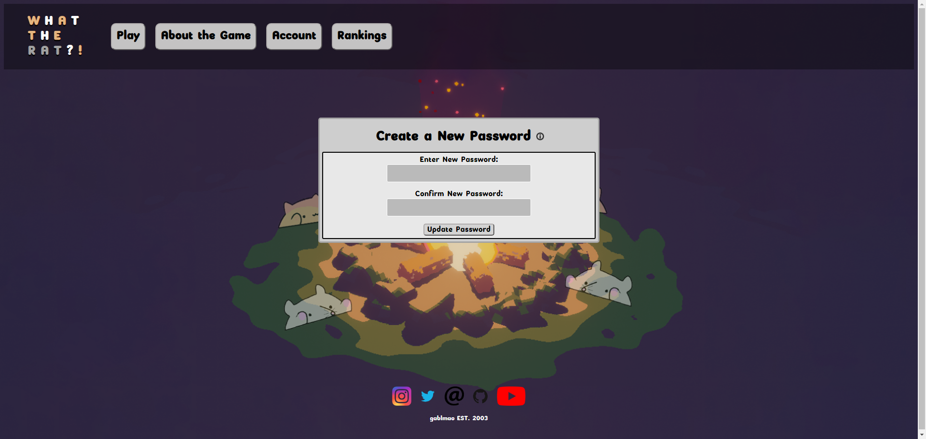

There’s a small image where if you were to hover your mouse over it, a small text box appears.

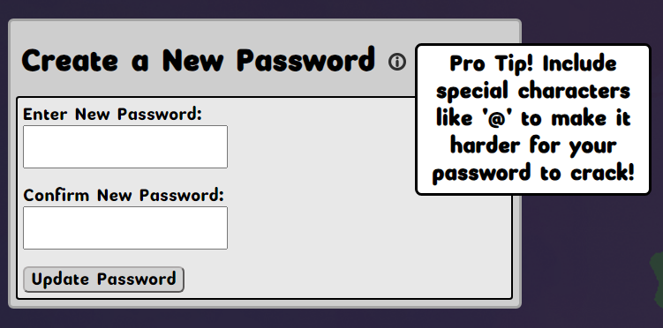

Ranking Page:

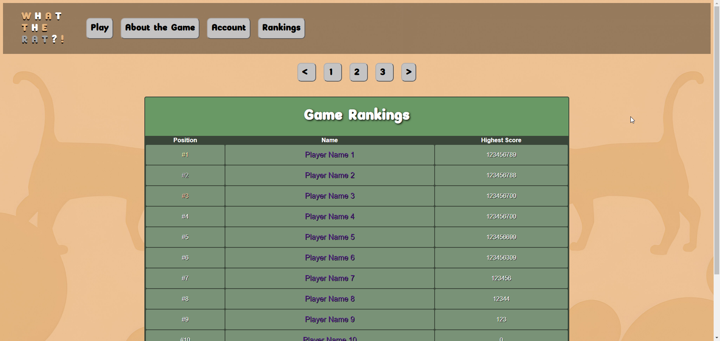The names in the ranking table have links which would lead to their individual account pages (see 2nd account page image).